

v1.0

31-August-2022

USER MANUAL

AZURE POWERSHELL TEMPLATE 3NIC-NVM-VMSS

# PATENT PROTECTION

A10 Networks, Inc. products are protected by patents in the U.S. and elsewhere. The following website is provided to satisfy the virtual patent marking provisions of various jurisdictions including the virtual patent marking provisions of the America Invents Act. A10 Networks, Inc. products, including all Thunder Series products, are protected by one or more of U.S. patents and patents pending listed at: a10-virtual-patent-marking.

# TRADEMARKS

A10 Networks, Inc. trademarks are listed at: a10-trademarks.

# CONFIDENTIALITY

This document contains confidential materials proprietary to A10 Networks, Inc. This document and information and ideas herein may not be disclosed, copied, reproduced, or distributed to anyone outside A10 Networks, Inc. without prior written consent of A10 Networks, Inc.

# DISCLAIMER

This document does not create any express or implied warranty about A10 Networks, Inc. or about its products or services, including but not limited to fitness for a particular use and non-infringement. A10 Networks, Inc. has made reasonable efforts to verify that the information contained herein is accurate, but A10 Networks, Inc. assumes no responsibility for its use. All information is provided "as-is." The product specifications and features described in this publication are based on the latest information available; however, specifications are subject to change without notice, and certain features may not be available upon initial product release. Contact A10 Networks, Inc. for current information regarding its products or services. A10 Networks, Inc. products and services are subject to A10 Networks, Inc. standard terms and conditions.

# ENVIRONMENTAL CONSIDERATIONS

Some electronic components may possibly contain dangerous substances. For information on specific component types, please contact the manufacturer of that component. Always consult local authorities for regulations regarding proper disposal of electronic components in your area.

# FURTHER INFORMATION

For additional information about A10 products, terms and conditions of delivery, and pricing, contact your nearest A10 Networks, Inc. location, which can be found by visiting [www.a10networks.com](http://www.a10networks.com).

Contents

PATENT PROTECTION 1

TRADEMARKS 1

CONFIDENTIALITY 1

DISCLAIMER 1

ENVIRONMENTAL CONSIDERATIONS 2

FURTHER INFORMATION 2

Introduction to Installing vThunder on Microsoft Azure 5

Overview of Microsoft Azure 5

Azure Terminology 8

System Requirements 9

Pre-requisites 14

Installation vThunder on Microsoft Azure 16

Chapter 1 - Core vThunder Installation & Basic Setup. 16

Configure 16

Install 19

Verify 20

Configure – Client Servers VMSS Setup 22

Verify 28

Chapter 2 - Automation Account Setup. 28

Configure Azure Access Key 28

Configure 45

Install 49

Verify 50

Create Runbook 50

Chapter 3 - Automation Account Webhook Setup. 51

Install 52

Verify 53

Chapter 4 – Enable Autoscaling 56

1. Autoscaling & Log Monitoring using Agent Setup. 57

2. Autoscaling using Azure Functions Setup 69

Chapter 5 - Let us Verify. 71

Login to vThunder 71

# Introduction to Installing vThunder on Microsoft Azure

vThunder for Microsoft Azure is a fully operational, software-only version of the ACOS Series Server Load Balancer (SLB), or Application Delivery Controller (ADC) device. It is configurable by ACOS CLI, GUI, AXAPI, and Harmony Controller. For more information see Virtual Instances in Harmony Controller.

vThunder is a virtual appliance, yet it retains most of the functionality available on the hardware based ACOS appliances. Managing vThunder is the same as managing hardware based ACOS device, and vThunder has the same CLI configurations and GUI presentation.

The networking configuration for vThunder is also like hardware based ACOS devices. The maximum throughput of vThunder for Azure is variable and depends on vThunder software license purchase and type instance used to deploy vThunder.

*A10 Networks brings Out-Of-Box template to deploy vThunder along with multiple features and functionality with pre-defined format into azure cloud.*

Please refer below section for more details.

* Three Network Card Interface (3NIC).
* Any numbers of Virtual Machines (NVM).
* Server Load Balancer (SLB)
* A10 Global Licenses Manager (GLM).
* TLS/SSL Certification (SSL).
* vThunder Virtual Machine Auto scale set (VMSS).
* vThunder Internal Log Monitoring.

# Overview of Microsoft Azure

With the move to the cloud, many teams have adopted agile development methods. These teams iterate quickly. They need to repeatedly deploy their solutions to the cloud, and know their infrastructure is in a reliable state. As infrastructure has become part of the iterative process, the division between operations and development has disappeared. Teams need to manage infrastructure and application code through a unified process.

To meet these challenges, you can automate deployments and use the practice of infrastructure as code. In code, you define the infrastructure that needs to be deployed. The infrastructure code becomes part of your project. Just like application code, you store the infrastructure code in a source repository and version it. Any one on your team can run the code and deploy similar environments.

To implement infrastructure as code for your Azure solutions, use azure resource manager templates. The template is a json native file that defines the infrastructure and configuration for your project. The template uses declarative syntax, which lets you state what you intend to deploy without having to write the sequence of programming commands to create it. In the template, you specify the resources to deploy and the properties for those resources.

**Microsoft Azure** (formerly known as Windows Azure) is Microsoft’s cloud computing platform. Azure is an industry leader for both infrastructure-as-a-service (IaaS) and platform-as-a-ser- vice (PaaS). Azure offers a combination of managed and unmanaged services that lets customers deploy and manage their applications as they see fit.

The Azure cloud computing platform runs on Microsoft data center and is globally dis- tributed across more than a dozen countries. Such global distribution helps ensure customers receive high performance, regardless of where they are located.

Azure is flexible and can support virtually any operating system, from Windows to Linux, any programming language, from Java to C++, and any database, from SQL to Oracle. Azure also offers 99.95% uptime and is the platform that Microsoft uses to run many of its popular ser- vices, such as Bing, Skype, Xbox, and Office 365.

A10 Networks vThunder virtual device can be set up as an instance in Azure’s cloud and can be used to provide a robust server load balancing (SLB) service.

Microsoft Azure uses the following tools to create and manage resources:

**Azure Portal** - A web console to create and monitor Azure resources. For more information, refer to <https://azure.microsoft.com/en-in/features/azure-portal/>

**Azure PowerShell** - A set of cmdlets used for managing Azure resources from the command line. Launch Azure PowerShell from a browser within the Azure Cloud Shell or install the software on the system to start a local PowerShell session.

For more information, refer to <https://docs.microsoft.com/en-us/powershell/>

**Azure CLI—** Can also be launched from a browser within the Azure Cloud Shell or install the software on the system to start a local CLI session. For more information, refer to <https://docs.microsoft.com/en-us/cli/azure/overview?view=azure-cli-latest>

You **can** launch Cloud Shell from the top navigation bar of the Azure portal.

FIGURE 1-1: Launching Cloud Shell



The following figure shows how vThunder fits into the Microsoft Azure infrastructure.

FIGURE 1-2: vThunder for Microsoft Azure

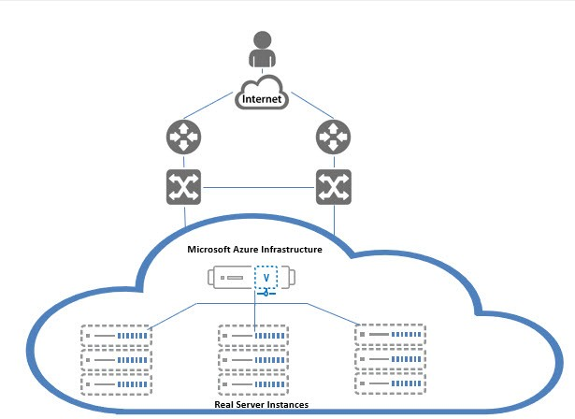

Below diagram shows process flow and different azure resources and system components are connected to each other’s.

FIGURE 1-3: vThunder for Microsoft Azure

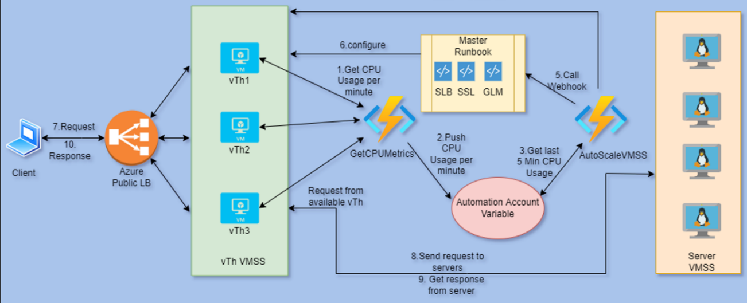`

# Azure Terminology

**Azure account** — The Azure account created has different support plans for different regions. For more information on different Azure regions and availability of types of virtual machines in these regions, refer to

<https://docs.microsoft.com/en-us/azure/virtual-machines/linux/overview>

**Resource group** — A resource group is a logical group of all the resources related to an Azure solution. Azure offers flexibility in the allocation of resources to resource groups.

For more information, refer to

[https://docs.microsoft.com/en-us/azure/azure-resource-manager/resource-group- overview](https://docs.microsoft.com/en-us/azure/azure-resource-manager/resource-group-%20overview/)

**Availability set** — An availability set is a logical grouping of Azure VM resources so that each VM resource is isolated from other resources when deployed. This hardware isolation ensures that a minimum number of VMs are impacted during a failure. For more information, refer to

[https://docs.microsoft.com/en-us/azure/azure-resource-manager/resource-group- overview](https://docs.microsoft.com/en-us/azure/azure-resource-manager/resource-group-%20overview/)

**Virtual network** — The Microsoft Azure Virtual Network service enables resources to securely communicate with other resources in an Azure network in the cloud. A virtual network is hence logical isolation of the Azure cloud for an Azure account. You can con- nect different virtual networks and to on-premises networks. For more information, refer to

[https://docs.microsoft.com/en-us/azure/virtual-machines/windows/tutorial-avail- ability-sets](https://docs.microsoft.com/en-us/azure/virtual-machines/windows/tutorial-avail-%20ability-sets/)

**Network security group (NSG)** — A network security group (NSG) contains a list of security rules that allow or deny network traffic to resources connected to Azure virtual networks (VNet). The NSGs can be associated with subnets or individual NICs attached to the VMs. When an NSG is associated with a subnet, the rules apply to all the resources connected to the subnet.

# System Requirements

Below all azure cloud resources will be created.

All templates come with default value it can be change while execution.

1. Azure Resource Group.

New resource group will be created with the specified name and location, in case does not exist.

Default name: *vth-rg1*

1. Azure Storage Account.

New storage account will be created inside resource group.

In case storage account already exists, it will prompt error “The storage account named is already taken”.

**Details:**

**Storage Account Name:** *vthunderstorage*

**Performance**: Standard

**Replication**: Read-access geo-redundant storage (RA-GRS)

**Account kind**: StorageV2 (general purpose v2)

**Storage Container:**

*ssl*

*vth-agent-cont*

1. Azure Automation Account

One automation account will be created with below details:

Default name: *vth-amt-acc*

1. Azure Runbook with Webhook.

Multiple run book will be created with below details.

Default name:

Event-Config

GLM-Config

GLM-Revoke-Config

Master-Runbook

SLB-Config

SSL-Config

1. Azure Log Analytics Workspace

A custom log analytics workspace is used to store all vThunder instances syslog. Custom agent fluentbit will sends all logs to log analytics.

Default name: *vth-vmss-log-workspace*

1. Azure Application Insight

A custom matrix will be created for data cpu utilization. According to threshold values it will be considered for autoscaling.

Default application insight name: *vth-vmss-app-insights*

Default custom metrics name: *vth-cpu-metrics*

Default threshold for autoscale-in is *25*%.

Default threshold for autoscale-out is *80*%.

1. Azure Load Balancer. [LB]

New load balancer with interface will be created in case does not exist.

In case to skip, just provide skip as an option while execution of script. Script will ask for this option.

Default name: *vth-lb1*

**Azure Load Balancer Rule:**

The load balancer rule is used to define how incoming traffic is distributed to **all** the vThunder instances within the backend pool.

Default three rules will get created “rulePort80”, “rulePort443”, “rulePort53”

**Back End Pool:**

The backend pool defines the group of resources that will serve traffic for a given load- balancing rule. It will attach with Network Interface Card 2 (NIC2)

Default name: *vth-lb1-bck-pool1*

**Health probes:**

A health probe is used to determine the health status of the vThunder instances in the backend pool.

Default three health probes will be created “HealthProbe80”, “HealthProbe443”, “HealthProbe53”

1. Virtual Machine Scale Set. [VMSS]

Default name: *vth-vmss*

1. Virtual Machine Instance.

**Basic Details:**

**Product: A10 vThunder**

**Instance Name:** *vth-user*

**Operating system**: Linux

**Default Size**: Standard_B4ms (4 vCPUs, 16 GiB Memory)

**Product:**  A10 Monitoring Agent

**Instance Name:** *vth-agent-inst1*

**Operating system**: Linux

**Size**: Standard DS2_V2 (2 vCPUs, 7 GiB Memory)

Note:

**Highly recommended to do assessment of your projected traffic before selecting any size.

** Instances name and size can be customized in parameter file.

**Supported VM Sizes**

|  |  |  |
| --- | --- | --- |
| ***Series*** | ***Size*** | ***Qualified Name*** |
| A series | Standard A4_v2  Standard A4m_v2  Standard/Basic A4  Standard A8_v2 | Standard_A4_v2  Standard_A4m_v2  Standard_A4  Standard_A8_v2 |
| B series | Standard B2_s  Standard B2ms  Standard B4ms | Standard_B2_s  Standard_B2ms  Standard_B4ms |
| D series | Standard D3_v2  Standard DS3_v2  Standard D5_v2 | Standard_D3_v2  Standard_DS3_v2  Standard_D5_v2 |
| F series | Standard F4s  Standard F8  Standard F16s | Standard_F4s  Standard_F8  Standard_F16s |

Few of sizes are getting retried soon from azure, please refer [Virtual Machine series | Microsoft Azure](https://azure.microsoft.com/en-in/pricing/details/virtual-machines/series/).

For more information, please refer as below.

<https://docs.microsoft.com/en-us/azure/virtual-machines/sizes-> [general](http://sales@a10networks.com/)

<https://docs.microsoft.com/en-us/azure/virtual-machines/linux/sizes>.

1. Virtual Cloud Network. [VCN]

Default address prefix for virtual network is 10.0.0.0/16.

Default name: *vth-vnet*

1. Subnets.

Total three subnets will be created. Address prefix can be configured in parameter file.

Default value:

*10.0.1.0/24*

*10.0.2.0/24*

*10.0.3.0/24*

1. Public and Private IP address.

Single frontend static public IP will be created and attached to LB interface.

Default public IP name: *vth-lb1-ip*

Default frontend IP name: *vth-lb1-frnt-ip*

1. Network Security Group. [NSG]

Default all interfaces are associated with security group.

Default name: *vth-nsg1*

Default Security Rules:

1. Network Interface Card. [NIC]

Default name:

*vth-inst1-mgmt-nic1*

*vth-inst1-data-nic2*

*vth-inst1-data-nic3*

Each vThunder consist of two types of NIC.

* Management Interface with public IP
* Data Interfaces with private IP. [Ethernet 1, Ethernet 2]

Note: Interfaces holds IP from DHCP.

# Pre-requisites

Please find below detailed pre-requisites to install template using POWERSHELL.

1. Azure account and valid subscription.

Azure Portal—A web console to create and monitor Azure resources. For more information, refer to <https://azure.microsoft.com/en-in/features/azure-portal/>

1. Azure CLI— Can also be launched from a browser within the Azure Cloud Shell or install the software on the system to start a local CLI session. For more information, refer to <https://docs.microsoft.com/en-us/cli/azure/overview?view=azure-cli-latest>

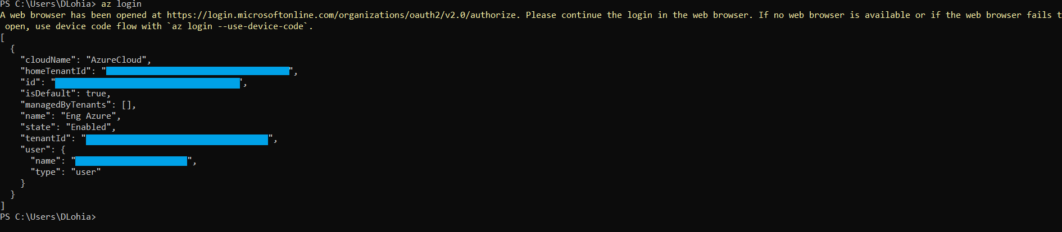

1. Windows PowerShell 7.0.6 LTS or 7.1.3, 7.2.2 or any higher. Recommended 7.2.2.

[Installing PowerShell on Windows - PowerShell | Microsoft Docs](https://docs.microsoft.com/en-us/powershell/scripting/install/installing-powershell-on-windows?view=powershell-7.2)

Azure PowerShell—A set of cmdlets used for managing Azure resources from the command line. Launch Azure PowerShell from a browser within the Azure Cloud Shell or install the software on the system to start a local PowerShell session. For more information, refer to <https://docs.microsoft.com/en-us/powershell/>

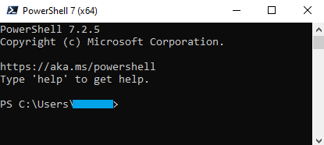  
Install Az Modules: Install-Module Az



1. Policy Setting in PowerShell.

Set execution policy to Unrestricted:

Set-ExecutionPolicy -Scope Process -ExecutionPolicy Bypass



1. Generate SSL certificate to apply on vThunder (Optional).
2. Document editor Notepad++ or Notepad or Any.

[Downloads | Notepad++ (notepad-plus-plus.org)](https://notepad-plus-plus.org/downloads/)

1. A10 GLM account access and valid available licenses.

For more details:

<https://glm.a10networks.com/>.

Below details required in template execution:

{  
 "userName": "<glm-portal-user-email>",  
 "userPassword": "<glm-portal-password>",  
 "entitlementToken": "<glm-license-entitlement-token>",  
 "licenseId": "<glm-license-id>"  
}

1. Artifacts:
2. [https://gitlab.a10networks.com/ax/a10-azure-arm-templates-internal/-/tree/feature/CLOUD-355/POWERSHELL-TEMPLATES/POWERSHELL-3NIC-VMSS](https://gitlab.a10networks.com/ax/a10-azure-arm-templates-internal/-/tree/feature/CLOUD-355/POWERSHELL-TEMPLATES/POWERSHELL-3NIC-VMSS )

# Installation vThunder on Microsoft Azure

## Chapter 1 - Core vThunder Installation & Basic Setup.

### Configure

Refer POWERSHELL_TMPL_3NIC_NVM_VMSS_PARAM.json file to customize default values. Please find below in details.

**Setting vThunder Default Credentials**

Default credential is mentioned in below image, this is only required during VM creation.

Username: *vth-user*

Password: *vth-Password*

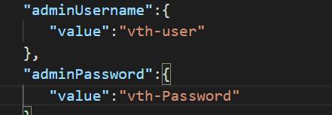

Note: vThunder will get provision using above credential but those are temporary. As soon as it gets provision, vThunder will auto delete all users other than default user.

So, use below credentials for login.

Username: admin

Password: a10

**VMSS Name**

**VMSS Size [VThunder]**

Any size which supports at least 3 NIC.

Please refer ‘Qualified Name’ column under supported vm sizes section to select any other size.

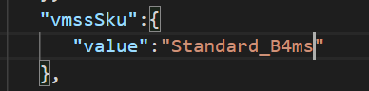

**VM Name**

Default vthunder monitoring VM name.

**VM Size [Agent]**

Default size is set as below. It can be changes as per needs. Please refer ‘Qualified Name’ column under supported vm sizes section to select any other size. All sizes works for this instance.

**vThunder Image**

User can pick available image from Azure marketplace.

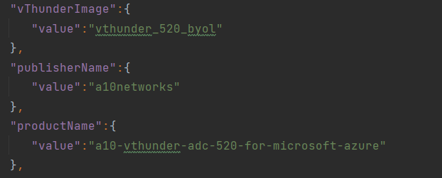

**Network Interfaces Card**

**Subnets**

Default subnets value

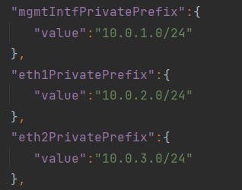

**Network Security Group**

**DNS Label Prefix – vThunder Host Name**

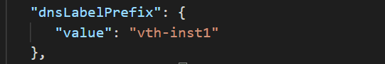

**DNS Label Prefix1 – vThunder Agent Host Name**

**Instance Count**

Instance count can’t be less than 1.

**NIC1 Public IP Name – vthunder management IP**

**Storage Account Name**

If storage account is already existed, script will give the error “The storage account named is already taken.”

**SSL Container Name**

User can’t change the **sslcontainerName** variable.

**Log Agent Container Name**

**Load balancer Name**

**LB Public IP Name**

**LB Frontend IP Name**

**LB Backend Pool Name**

### Install

1. Create azure resource group manually.

Default name: *vth-rg1*

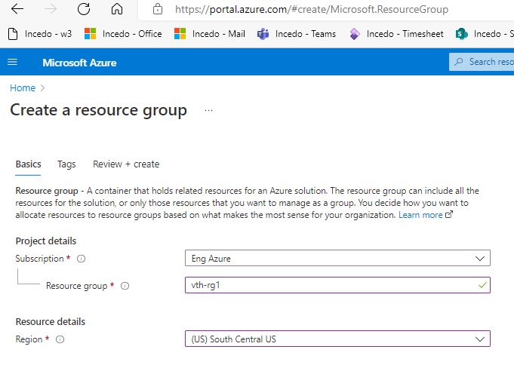

2. Open PowerShell 7 from start menu.

3. Edit parameter file PS_TMPL_3NIC_NVM_VMSS_PARAM.json

Run below command

.\PS_TMPL_3NIC_NVM_VMSS_1.ps1 -resourceGroupName vth-rg1 -location “South Central US”

### Verify

**Verify VMSS**

Virtual machine scale set is a group of all instances. As per instance count mentioned in [PS_TMPL_3NIC_NVM_VMSS_PARAM.json] default is 1, vmss automatically creates vThunder instances.

In any case [either manually or auto] instance gets deleted vmss creates new one.

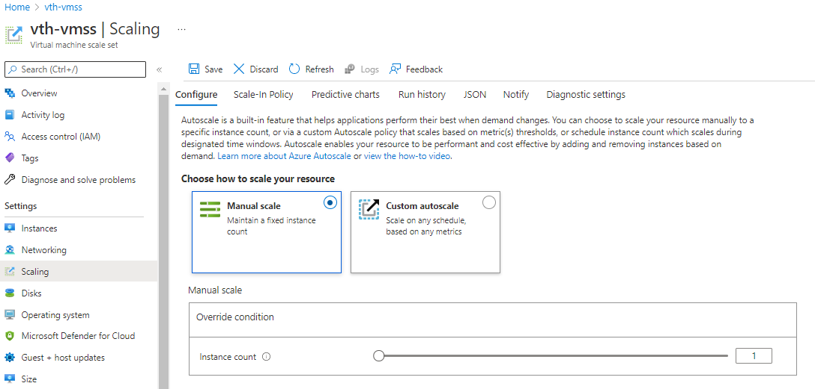

**Verify LB**

Check and confirm the configurations below on Azure portal.

* 1. Load balancer -> Frontend IP configuration

* 1. Load balancer -> Backend pools

* 1. Load balancer -> Health probes

* 1. Load balancer -> Load balancing rules

**Verify Storage Account**

Check the below configurations on Azure portal.

1. Storage account
2. Storage account -> Containers

### Configure – Client Servers VMSS Setup

Go to Azure Portal-> Virtual machine scale sets -> Create

Add basic information.

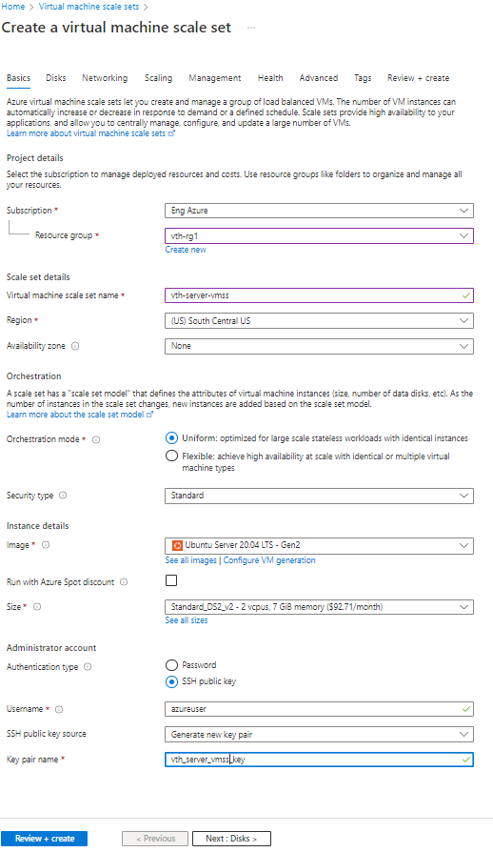

Select Next.

Select/Update as above and Click on Edit Network Interface.

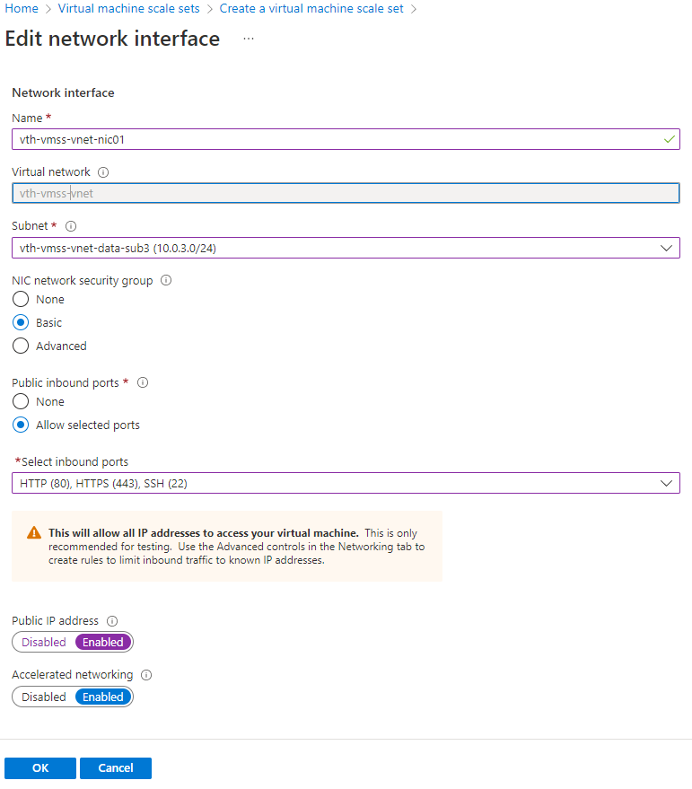

Select OK.

Select Next

Review

Create

Download private key and create resource.

Wait for some time. Finally you will see resources created.

### Verify

Network Configuration:

VMSS will have only 1 interface and port 80 and port 443 should be present in inbound rules.

## Chapter 2 - Automation Account Setup.

### Configure Azure Access Key

Azure access key is required to access resources. To create the Azure access key, perform the following steps:

1. Create a Role
2. Register a Service Application
3. Associate Service Application with a Role
4. Create Certificate and Secrets
5. Collect Azure Access Key
6. Importing Azure Access Key

#### 1. Create a Role

To create a custom role, perform the following steps:

1. Navigate to the Home > Subscriptions > Registered Subscription Name > Access control (IAM) from left panel.

FIGURE 3-1: Subscriptions - Access control (IAM) window

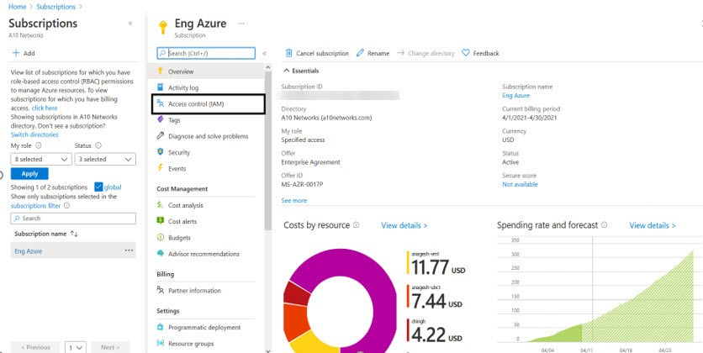

1. On the Select Access control (IAM) page, select the Roles tab. The Role window is dis- played.

FIGURE 3-2: Access Control - Role Window

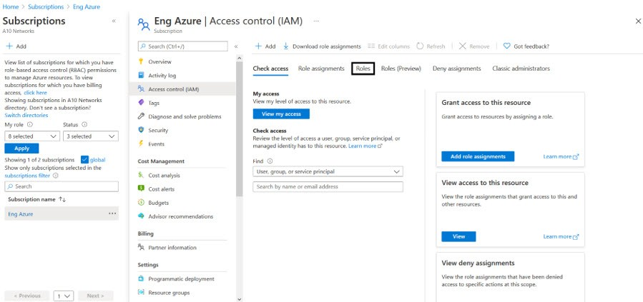

1. Click on the +Add tab and select Add custom role option. The Create a custom role window is displayed.

FIGURE 3-3: Add custom role window

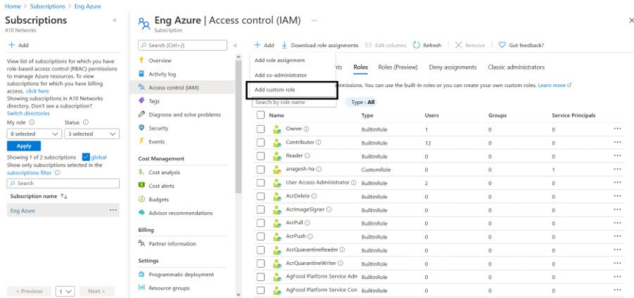

1. Enter Customer role name and Description (optional).

FIGURE 3-4: Create a custom role window

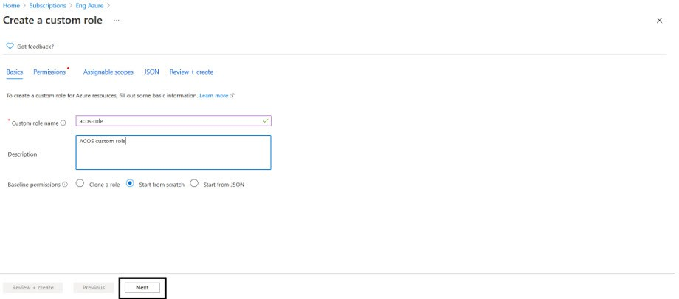

1. Click on the **Next** button. The Permission window is displayed.

*FIGURE 3-5: Permission window*

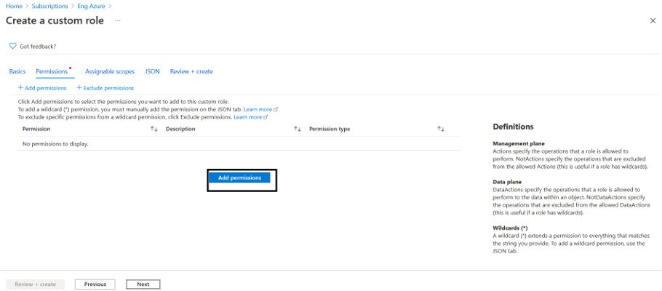

1. Click on the **+Add Permissions** button to create a custom role.
2. Search for the permission to add the custom role.

For example, select **Microsoft Compute** from Add Permissions page.

*FIGURE 3-6: Add permission window*

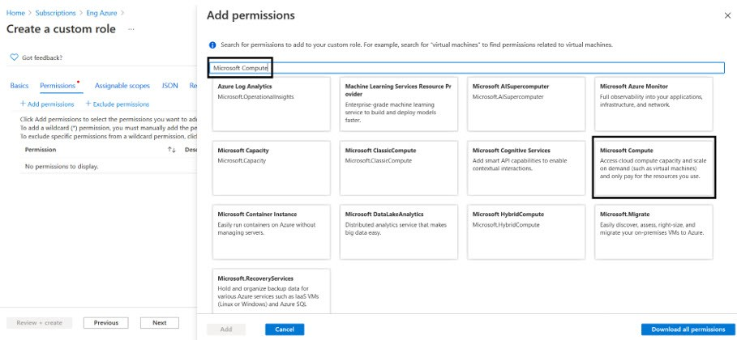

The Microsoft Compute permission window is displayed.

*FIGURE 3-7: Microsoft Compute permissions window*

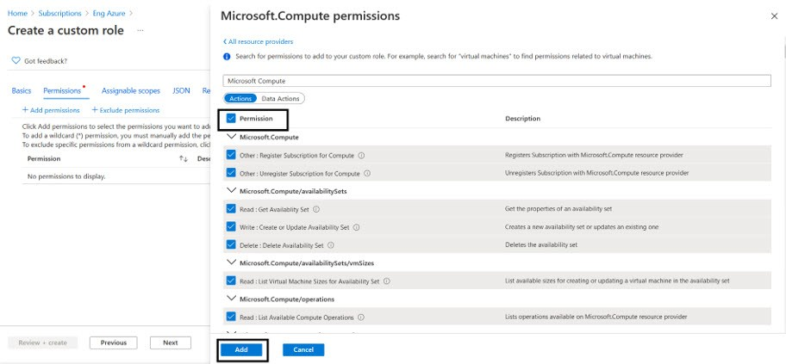

1. Select the **Permission** check box(es) and click **Add** button.
2. To add **Microsoft Network** from Add Permissions page, click on the **+Add Permissions**

on Create a custom role page.

*FIGURE 3-8: Create a custom role - Add permissions*

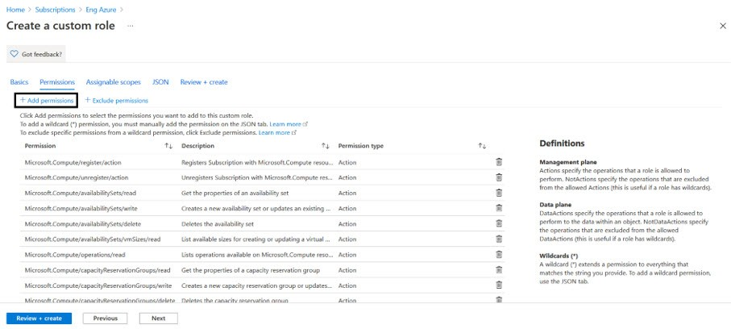

1. Search and select **Microsoft Network** from Add Permissions page.

*FIGURE 3-9: Add permissions - Microsoft Network page*

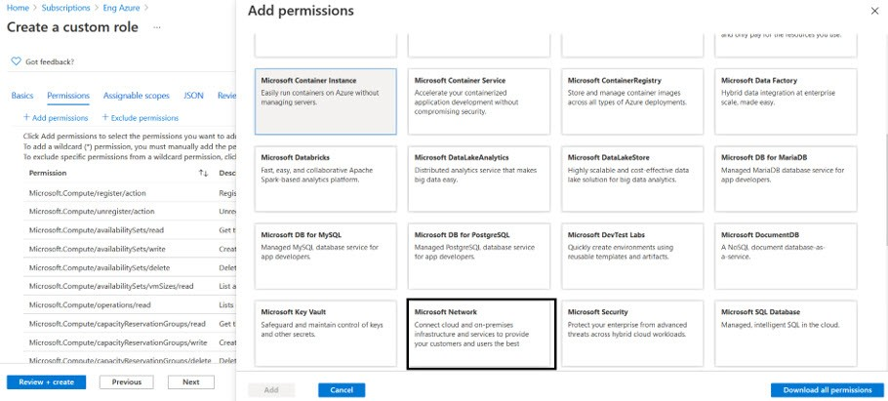

1. Select the **Permission** check box and click **Add** and **Review + create**.

*FIGURE 3-10: Microsoft Network permissions window*

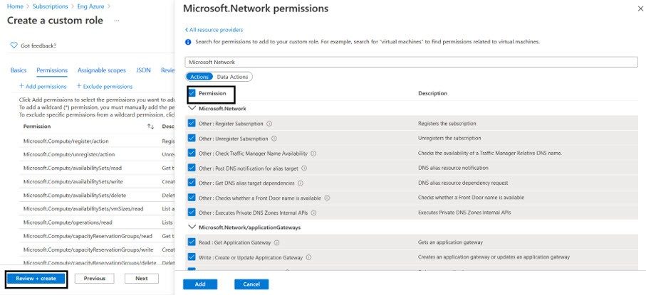

The **Create a custom role** confirmation window is displayed.

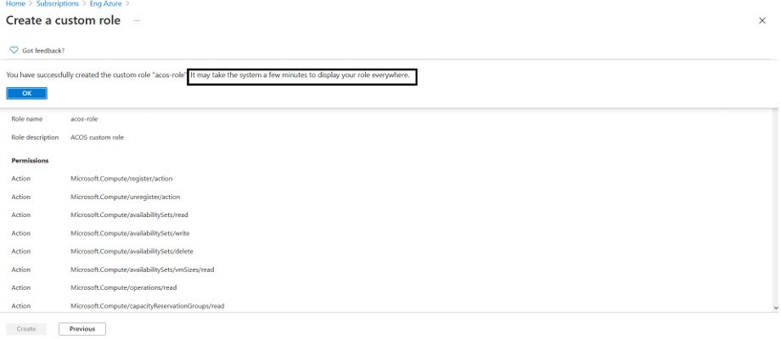

1. Click OK to successfully create the custom role with permissions.

**NOTE:** It may take the system a few minutes to display your role everywhere.

#### 2. Register a Service Application

To register a service application, perform the following steps:

1. Navigate to the Home > Services > Azure Active Directory option.

*FIGURE 3-11: Azure Active Directory page*

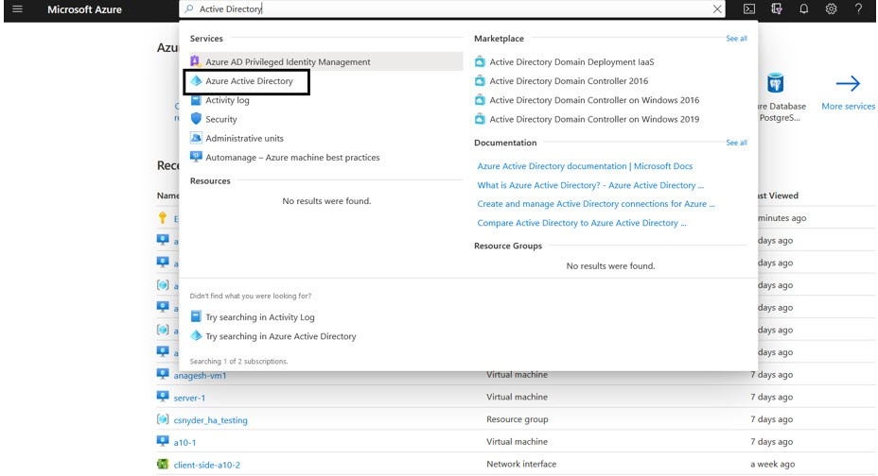

1. On the Azure Active Directory page, click on the App registrations menu option from the left panel. The App registration window to register an application is displayed.

*FIGURE 3-12: App registrations window*

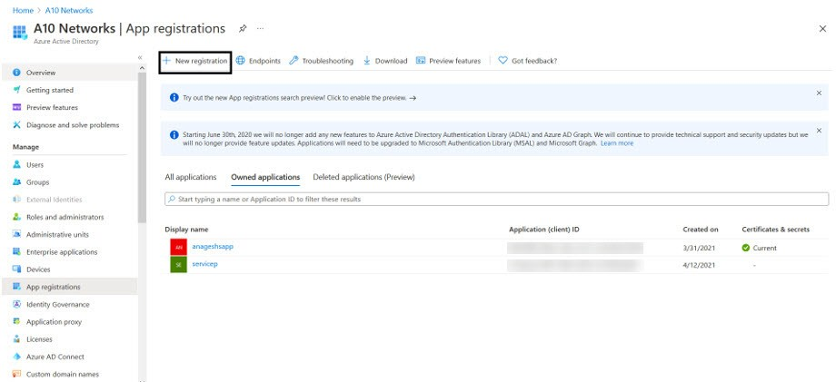

1. Click on the **+New Registration** tab. The Register an application window is displayed.

*FIGURE 3-13: Register an application window*

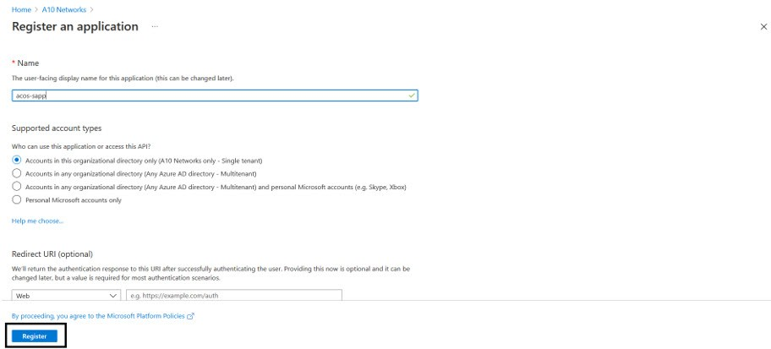

1. Enter the **Name** of the application. For example, acos-sapp.
2. Click on the **Register** button to register the application. The application gets displayed in the list of Azure Active Directory - Apps registrations window.

#### 3. Associate Service Application with a Role

To associate service application with a created role, perform the following steps:

1. Navigate to the **Home** > **Subscriptions** > **Registered Subscription Name** > **Access control (IAM)**.

The Subscription > Access control (IAM) window is displayed.

*FIGURE 3-14: Subscription - Access control (IAM) window*

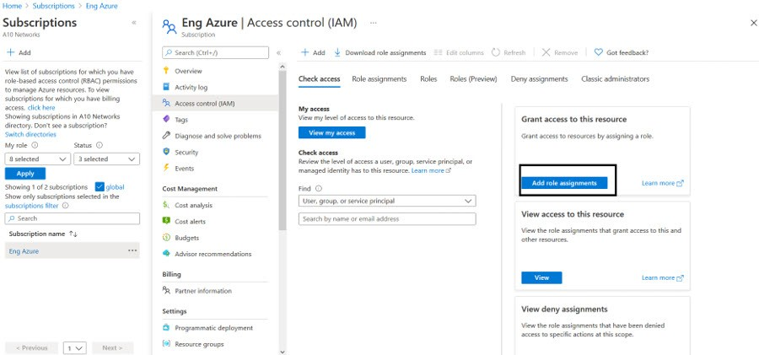

1. To assign a role to the above scope, click the **+ Add** tab from the main menu options. The Add role assignment window is displayed.

*FIGURE 3-15: Add a role assignment -1*

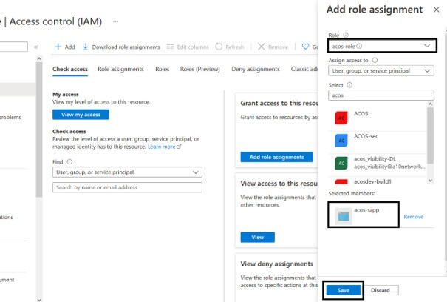

1. Select a **Role** from the drop-down list. For example, acos-role.
2. Select the **Assign Access to** option from the drop-down list.
3. Enter a string to search and select for a name or email address. For example, acos.
4. Click the **Save** button to save the configuration.

#### 4. Create Certificate and Secrets

To create certificate and secrets for the assigned role, perform the following steps:

1. Navigate to the **Home** > **Services** > **Azure Active Directory** option.

*FIGURE 3-16: Azure Active Directory - Overview page*

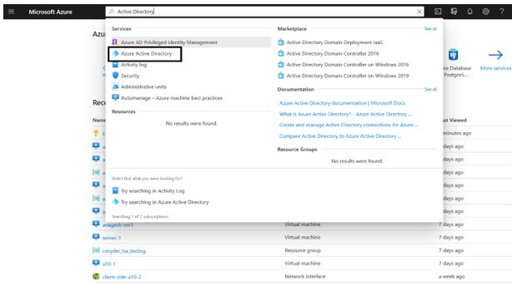

1. On the Azure Active Directory - Overview page, click on the App registrations menu option from the left panel. The App registration window with a registered application(s) is displayed.

*FIGURE 3-17: App registrations - Overall applications window*

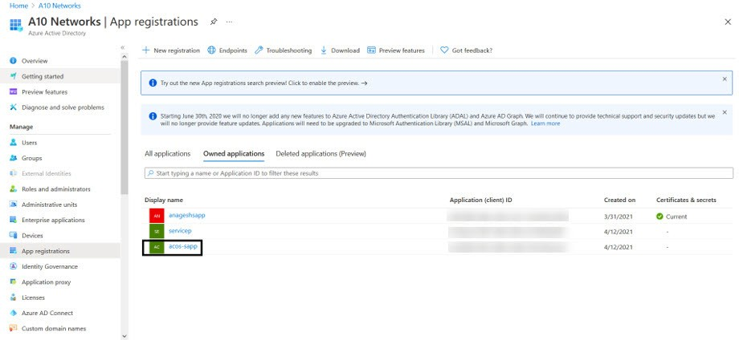

1. Select a service application from list of applications. The selected service application window is displayed.
2. Select the **Certificates & secrets** option from the left Manage navigation pane. The acos app - Certificates & secrets window is displayed.
3. Select the **Start date** and **Expires** date from the date picker.

Or Click the **New client secret** button. The Add a client secret window is displayed.

*FIGURE 3-18: Add a client secret window*

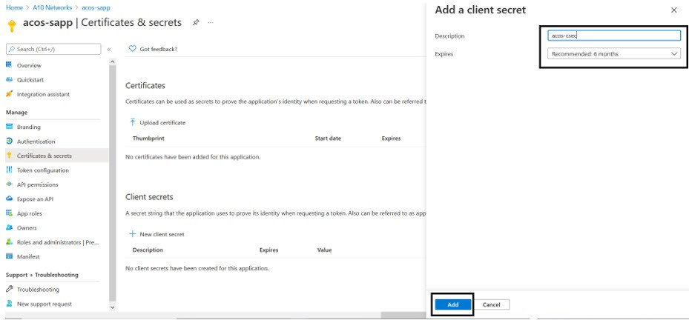

1. Enter the New client secret **Description**, **Expires** value. The entered value is displayed on the acos-Certificates & secrets window.

*FIGURE 3-19: acos-app Certificates & secrets window*

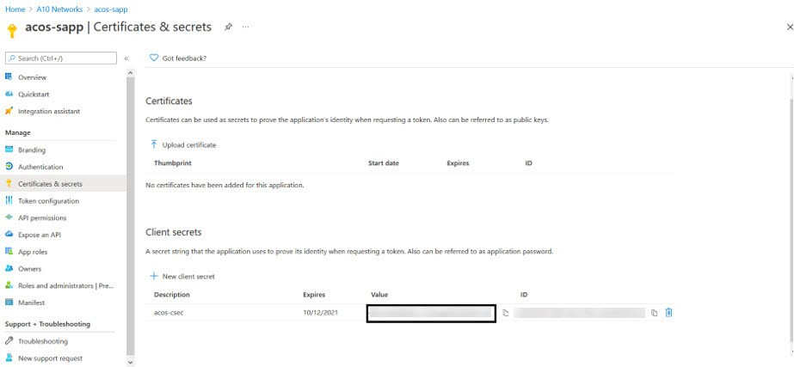

NOTE:

Copy the new client secret value, as it is not visible once the page is refreshed.

#### 5. Collect Azure Access Key

To collect Azure access keys, perform the following steps:

1. Navigate to the **Home** > **Azure Active Directory** - **App registrations**.

*FIGURE 3-20: App registrations - Azure Active Directory window*

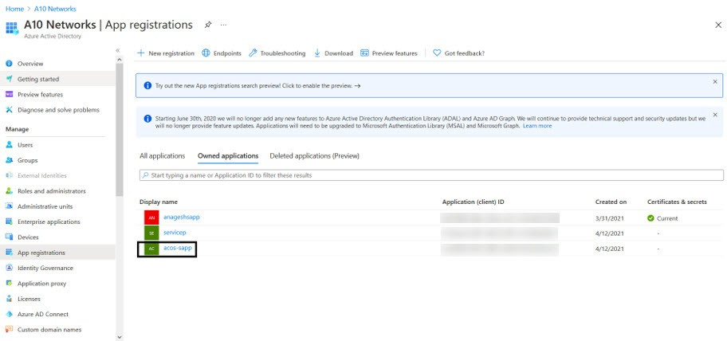

1. Select service application from the list of applications. The selected service application page is displayed.

*FIGURE 3-21: Selected Service application window*

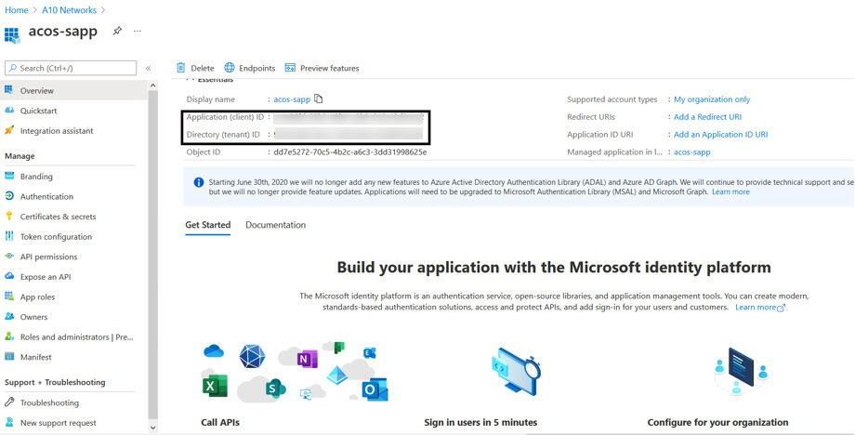

1. Copy the Client ID, Tenant ID from the service application page. client_id= 'cc4c86xx-65b3-48xx-a3xx-610cxxxxxxxx’ tenant_id= '91d27axx-8cxx-41xx-82xx-3d1bxxxxxxxx'
2. Navigate to the **Home** > **Subscriptions** > **Registered Subscription Name** and copy subscription ID value.

*FIGURE 3-22: Subscriptions window*

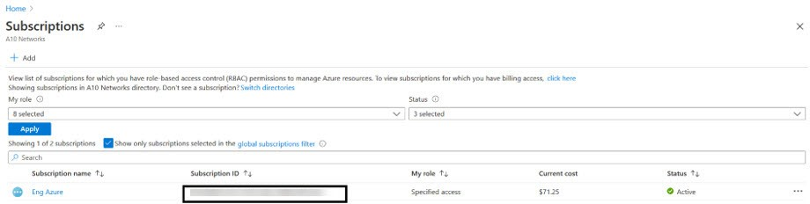

1. Create a text file with as subscription, client_id, client_secret and tenant_id as shown below:

subscription='07d34bxx-61xx-47xx-abxx-006bxxxxxxxx'

client_id='cc4c86xx-65xx-48xx-a3xx-610cxxxxxxxx’ client_secret='G0x_hVDzZxxxx-o1Vsw.xxxx.Zxxxx-xx' tenant_id='91d2xxxx-8xxe-41xx-82xx-3d1bxxxxxxxx’

#### 6. Import Azure Access Key

Each vThunder instance requires a copy of the Azure Access key. The recommended method of importing the Azure Access key by using any of the file transfer methods.

Perform the following steps.

1. Log into the vThunder instance.
2. Go to the config mode.

**vThunder>**enable

Password:

**vThunder#**config

1. Go to the admin mode.

**vThunder(config)#**admin ?

admin

NAME<length:1-31> System admin user name

**vThunder(config)#**admin admin

1. Import the Azure Access key by using any of the file transfer methods recommended.

**vThunder(config-admin:admin)#azure-cred import ?**

use-mgmt-port Use management port as source port

tftp: Remote file path of tftp: file system(Format: tftp://host/file) ftp: Remote file path of ftp: file system(Format: ftp://[user@]host[:port]/file)

scp: Remote file path of scp: file system(Format: scp://[user@]host/file)

sftp: Remote file path of sftp: file system(Format:

sftp://[user@]host/file)

To delete the key, use the command **Azure-cred delete**.

1. Verify the imported Azure Access keys by below mentioned commands:

vThunder-Active(config)(NOLICENSE)#admin ad vThunder-Active(config)(NOLICENSE)#admin admin

vThunder-Active(config-admin:admin)(NOLICENSE)#azure-cred import scp://user- name@<ip-addr>:/<file-path>/cred.txt

vThunder-Active(config-admin:admin)(NOLICENSE)#azure-cred sh vThunder-Active(config-admin:admin)(NOLICENSE)#azure-cred show SUB_ID = 'dfe16a52-xxxx-xxxx-xxxx-91767a54xxxx'

client_id = 'cc4c86xx-65b3-48xx-a3xx-610cxxxxxxxx’

secret = 'xxxx_XGEd9u0xxxx2Css=xxxx?8bf-0b'

tenant = '1e94dxxx-xxxx-xxxx-xxxx-3b3e1b64xxxx'

vThunder-Active(config-admin:admin)(NOLICENSE)#

### Configure

Please refer PS_TMPL_3NIC_NVM_VMSS_RUNBOOK_VARIABLES.json

Needs to update few parameters:

|  |  |  |  |
| --- | --- | --- | --- |
| S.No | Name | Encryption | Value |
| 1 | azureAutoScaleResources  Get Tenant ID and App ID/ClientID from here.  You can get while access key generation section.  No need to update masterWebhookUrl it will be get updated automatically. | No | {  "resourceGroupName": "*vth_rg1*",  "automationAccountName": "*vth-amt-acc*",  "vThunderScaleSetName": "*vth-vmss*",  "serverScaleSetName": "*vth-server-vmss*",  "storageAccountName": "*vthunderstorage*",  "appId": "*XXX*",  "tenantId": "*XXX*",  "masterWebhookUrl": *"<master-runbook-webhook-url>*",  "location": "*South Central US*"  } |
| 2 | autoScaleParam  Set as per your needs. This params will applied only for function base autoscaling. Ignore for agent base autoscaling. | No | {  "maxScaleOutLimit": 10,  "minScaleInLimit": 1,  "scaleInThreshold": 25,  "scaleOutThreshold": 80 } |
| 3 | clientSecret  Get clientSecret from here. You can get while access key generation section. | Yes | "clientSecret": "XXX” |
| 4 | glmParam  Get from [glm account](https://glm.a10networks.com/). | Yes | {  "userName": "<glm-portal-user-email>",  "userPassword": "<glm-portal-password>",  "entitlementToken": "<glm-license-entitlement-token>",  "licenseId": "<glm-license-id>" } |
| 5 | slbParam | No | {  "slb_port":{  "value":[  {  "port-number": 53,  "protocol": "udp",  "health-check-disable":1  },  {  "port-number": 80,  "protocol": "tcp",  "health-check-disable":1  },  {  "port-number": 443,  "protocol": "tcp",  "health-check-disable":1  }  ]  },  "vip_port":{  "value": [  {  "port-number":53,  "protocol":"udp",  "ha-conn-mirror":1,  "auto":1,  "service-group":"sg53"  },  {  "port-number":80,  "protocol":"http",  "auto":1,  "service-group":"sg80"  },  {  "port-number":443,  "protocol":"https",  "auto":1,  "service-group":"sg443"  }  ]  },  "rib_list": [  {  "ip-dest-addr":"0.0.0.0",  "ip-mask":"/0",  "ip-nexthop-ipv4": [  {  "ip-next-hop":"10.0.2.1"  }  ]  }  ] } |
| 6 | sslParam  Path: Absolute path of SSL Certificate in pem format. | Yes | {  "requestTimeout": 40,  "path": "*server.pem*",  "file": "server",  "certificationType": "pem",  "containerName": "ssl",  "storageAccountKey":"<storage-account-access-key>" } |
| 7 | vCPUUsage | No | {} |
| 8 | vThunderIP | No | {} |
| 9 | agentPrivateIP | No | "<agent-machine-private-ip>" |

Note

1. If automation account does not exist, then a new automation account will be created inside resource group. If automation account already exists, then template will auto update it.
2. If automation account variable does not exist, then a new automation account variable will be created inside automation account variables. If automation account variable already exists, then it will give “The variable already exists. “Error.
3. resourceGroupName is name of resource group where virtual machine scale set having vThunder servers and resources created by POWERSHELL template are present.
4. vmssName is name of virtual machine scale set containing vThunder servers.
5. agentPrivateIP is private IP of agent VM.

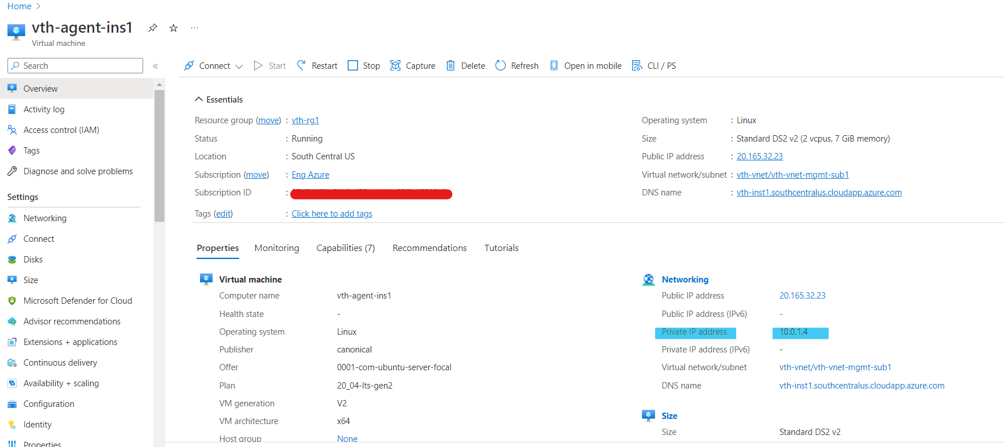

1. App Id and Tenant Id will get from App Registration.

Azure Console 🡪 Azure Active Directory 🡪 App Registration

1. clientSecret id will get from App Registration -> Certificates & secrets.
2. Fill out the GLM Portal details in glmParam

How to get “**GLM license Id”**

* 1. Login to the GLM portal
  2. Select the license and go to the URL, you will find the license id at end of the URL



1. Fill out the ssl file details in sslParam

How to get **Storage account -> Access keys -> Key**

### Install

Run PowerShell script to create an automation account. .\PS_TMPL_3NIC_NVM_VMSS_AUTOMATION_ACCOUNT_2.ps1

### Verify

Go to azure portal -> Resource Group -> Automation Account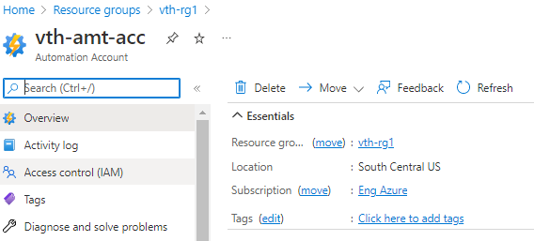

Go to azure portal -> Automation Account -> Variables

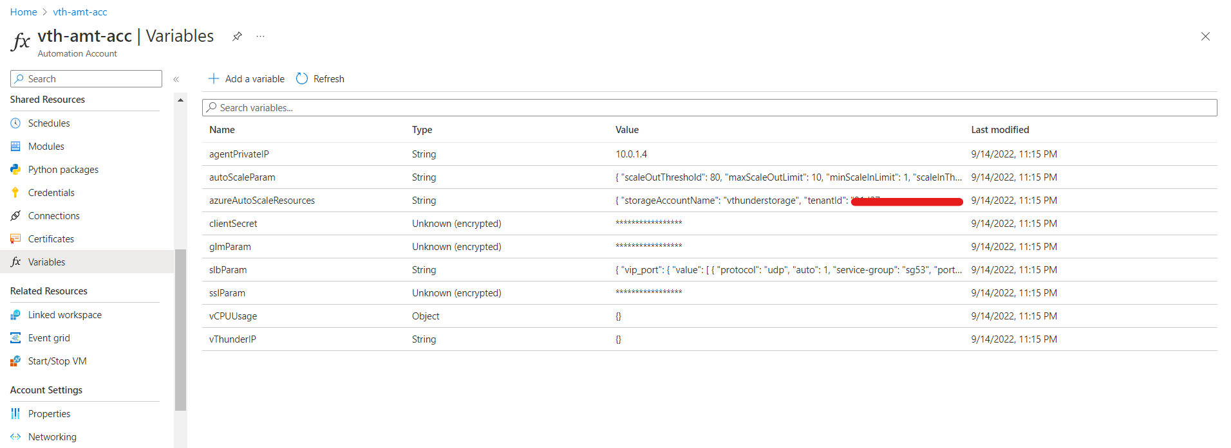

### Create Runbook

Go to Automation Account->Process Automation->Runbooks->Create a runbook for all below items.

1. Create a runbook with name [SLB-Config].

1. Once you click on create, wait for 30 sec after that you will see edit window.

1. Copy runbook [PS_TMPL_3NIC_NVM_VMSS_SLB_RUNBOOK.ps1] content.
2. Save.
3. Publish.

Repeat for all above five steps for all below runbooks.

* Create and Copy content of **PS_TMPL_3NIC_NVM_VMSS_SSL_RUNBOOK.ps1** into azure runbook with name “**SSL-Config**”.
* Create and Copy content of **PS_TMPL_3NIC_NVM_VMSS_GLM_RUNBOOK.ps1** into azure runbook with name “**GLM-Config**”.
* Create and Copy content of **PS_TMPL_3NIC_NVM_VMSS_GLM_REVOKE_RUNBOOK.ps1** into azure runbook with name “**GLM-Revoke-Config**”.
* Create and Copy content of **PS_TMPL_3NIC_NVM_VMSS_ACOS_EVENT_CONFIG_RUNBOOK.ps1** into azure runbook with name “**Event-Config**”.
* Create and Copy content of **PS_TMPL_3NIC_NVM_VMSS_MASTER_RUNBOOK.ps1** into azure runbook with name “**Master-Runbook**”.

## Chapter 3 - Automation Account Webhook Setup.

Note: Make sure your VMSS resource is in start mode.

In case you have stopped please start. Also confirm all instances are in running mode.

Above script will do all below actions automatically:

1. Generate URL for master runbook and update in automation variable section.
2. Upload SSL Certificate file to azure storage account.
3. Configure master runbook URL in variables.

### Install

.\PS_TMPL_3NIC_NVM_VMSS_WEBHOOK_3.ps1

Troubleshooting:

1) In case you face this error while executing,

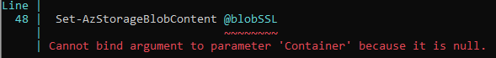

That means server.pem is not available or don’t have access at mentioned path, please check PS_TMPL_3NIC_NVM_VMSS_RUNBOOK_VARIABLES.json

2) In case you face this error while executing,



That means webhook url is not configured or already exist. Please delete[master-webhook] from azure portal and finally should be empty as below before running script.

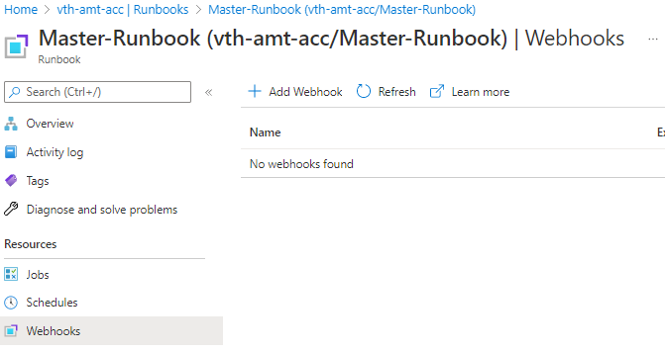

### Verify

#### Automation account variable

Go to the azure portal -> Automation account -> Variable -> Select “azureAutoScaleResources”

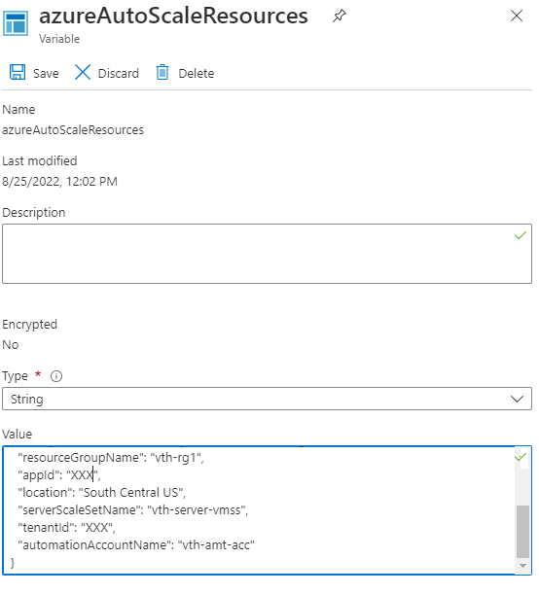

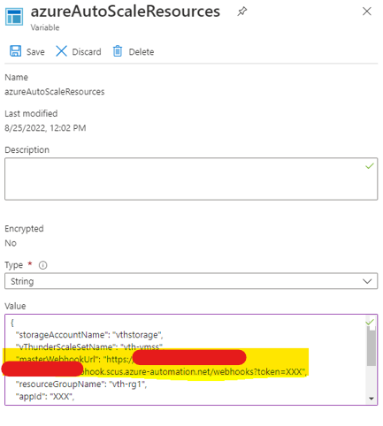

#### SSL File

Go to the azure portal -> Storage Account -> Containers -> ssl

#### Runbook Jobs

Go to the azure portal -> automation account -> Jobs

Verify all jobs in completed status.

Wait for 5 mins. All jobs will be triggered one by one automatically.

In case it failed or not worked. Re-Run Master Runbook. All other runbooks will be triggered by master runbook.

Click on each job and select “All Logs” to verify

Troubleshooting Tips:

In case any jobs have errors as below

Then, re-run master runbook, to re-run please follow below steps:

1. Delete vth-vmss all instances.

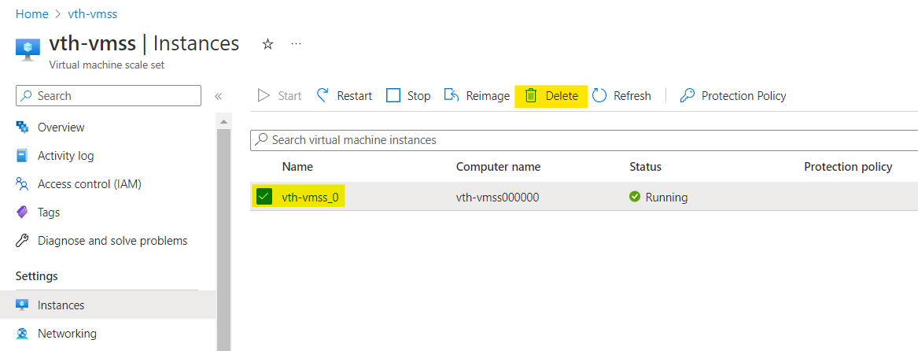

Wait for 1-2 mins. Once it is deleted, proceed further.

2. Re-Run Master Runbook.

Again, verify run-book jobs.

## Chapter 4 – Enable Autoscaling

There are two options for autoscaling. We must select anyone.

1. Autoscaling & Log Monitoring using Agent Setup:

Included:

1. Collects custom metrics of vThunder and publish into azure application insight service and same metrics can be used along with vmss rule for autoscaling.
2. CPU utilization alerts can be scheduled using vmss alert rule.
3. CPU utilization of thunder can be viewed in azure application insight console.
4. vThunder logs can be viewed in azure log analytics workspace.

2. Autoscaling using Azure Functions Setup

Included:

1. Custom azure functions collect cpu utilization metrics and does autoscaling on its own.

A10 Networks supports and recommend with option #1. Autoscaling with agent setup.

### 1. Autoscaling & Log Monitoring using Agent Setup.

PowerShell template to Install fluentbit and telegraf agent in VM

#### Configure

We need to configure below files,

1. PS_TMPL_3NIC_NVM_VMSS_LOG_AGENT_SHELL_SCRIPT.sh

* Update customer_id and shared_keyText

  Description automatically generated

customer_id is workspace ID

shared_key is primary key

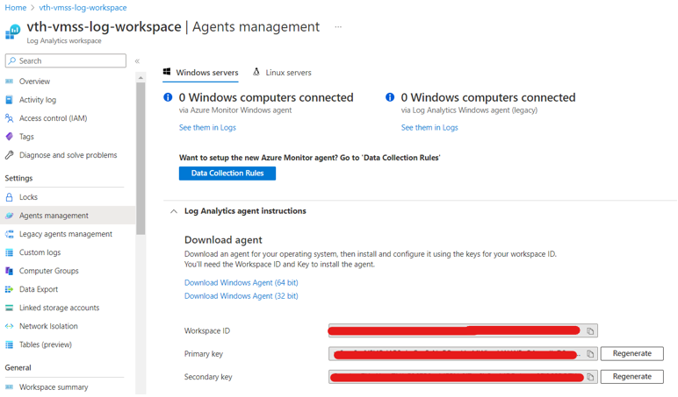

* Update app_insights_key is instrumentation key



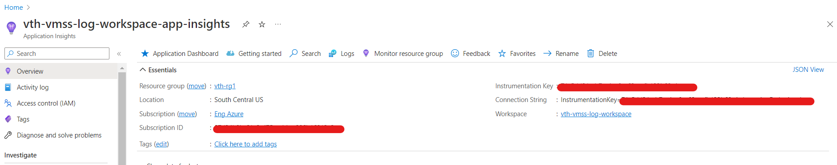

* Update AZURE_CLIENT_ID, AZURE_TENANT_ID, AZURE_CLIENT_SECRET







1. get_cpu_param.json

file path: a10-azure-arm-templates-internal/plugins/telegraf/plugins/inputs/customplugin/get_cpu_param.json

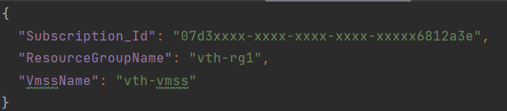

#### Install

.\PS_TMPL_3NIC_NVM_VMSS_LOG_AGENT_VM_5.ps1

After successfully execution, wait for 5-10 mins before starts to verify.

#### Verify

1. Check PS_TMPL_3NIC_NVM_VMSS_LOG_AGENT_SHELL_SCRIPT.sh file uploaded successfully.

Go to the azure portal -> Storage Account -> Containers -> vth-agent-cont

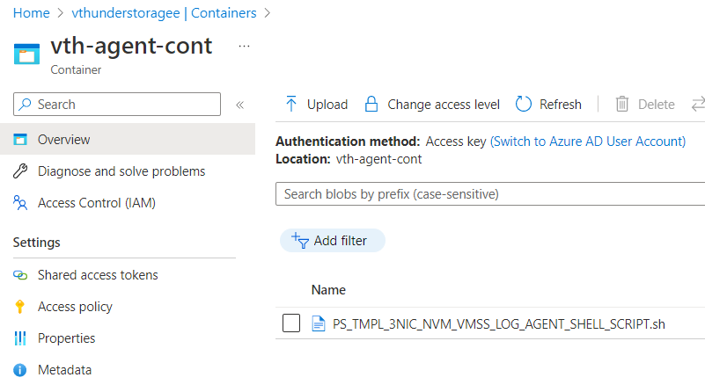

1. Login into agent VM

User can login using putty.

User ID can be determine from PS_TMPL_3NIC_NVM_VMSS_PARAM.json.

Values of adminUsername and adminPassword.

Default is

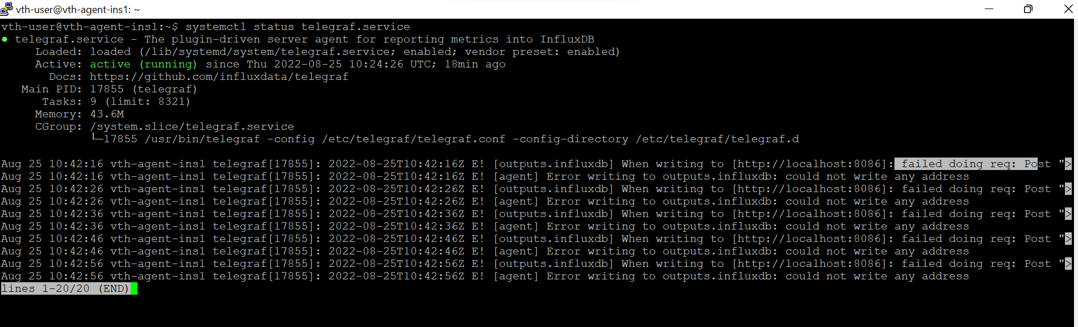

Note: Ignore errors: writing to outputs.influxdb

1. Log output in Log Analytics Workspace
2. Azure Portal -> Log Analytics workspaces -> vth-vmss-log-workspace -> Logs

Expand ‘Custom Logs’.

Double click on ‘vthunder-logs’

Click on Run.

All logs will get displayed in tabular and chart format along with expandable details.

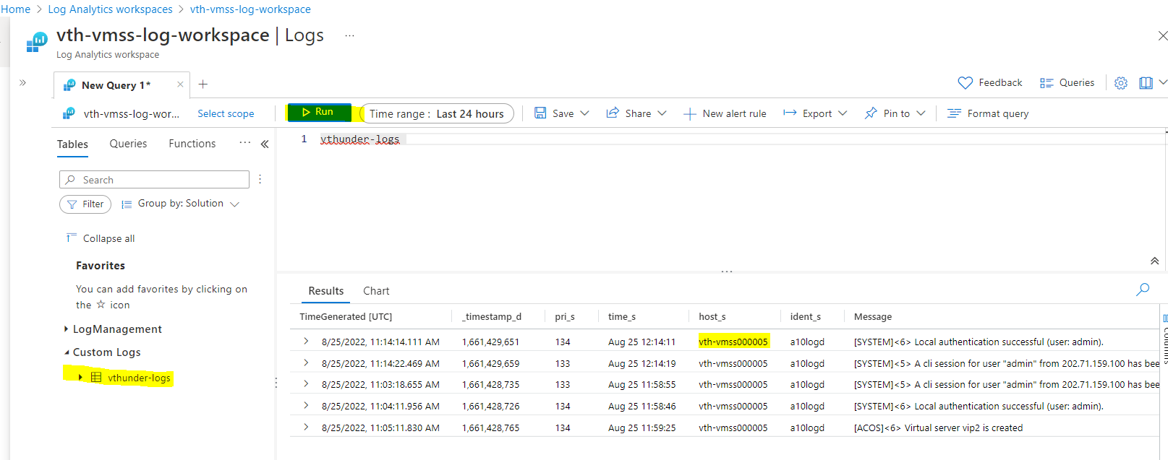

1. Azure Portal -> Application Insides-> vth-vmss-log-workspace-app-insights -> Logs

Expand ‘customMetrics’.

Double click on ‘customMetrics’

Click on Run.

All metrics logs will get displayed in tabular and chart format along with expandable details.

Each record is aggregated value for all vthunder instances. Value is data-cpu % utilization for every [interval-to-pull-vthunder-cpu-utilization: Default is 60 secs] configured in telegraf agent in agent instance.

#### Create Autoscale Rule

vThunder auto scaling rules needs to be created.

In the portal, locate the virtual machine scale sets -> *vth-vmss* -> scaling -> Custom autoscale

Select “Scale based on a metric”.

Select “Add a rule”

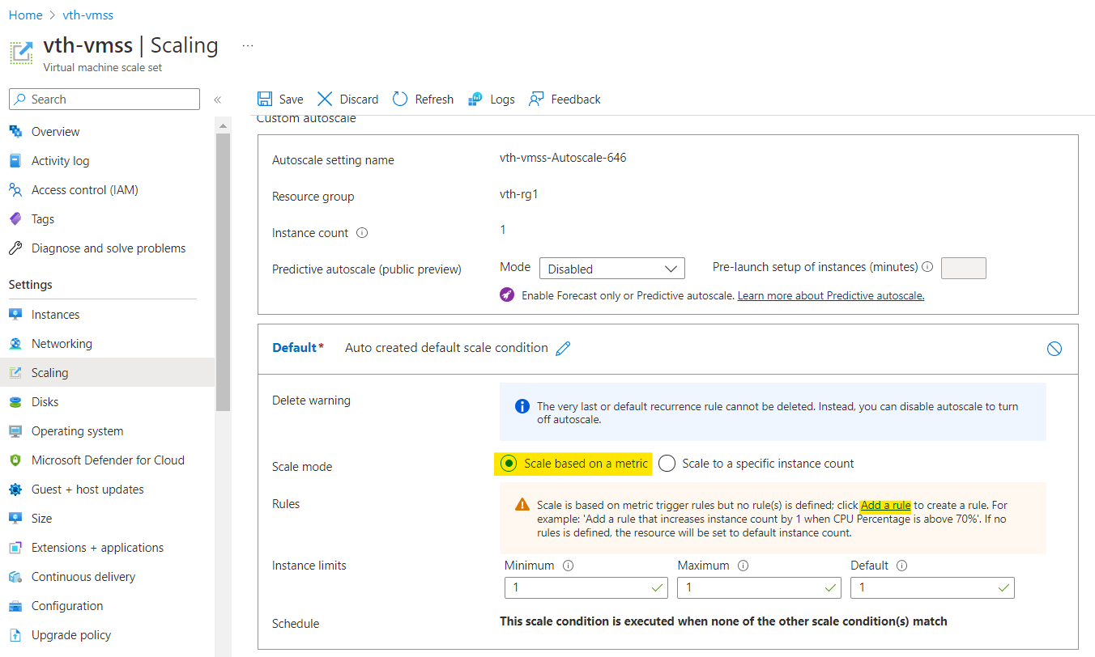

-> Add rule

Click Add

Save

Select “Notify”

Get webhook url from automation account variables.

Update webhook url as below:

#### Create Autoscale Alert

In the [portal](https://portal.azure.com/),

Step 1: Select the **New alert rule** button to open the **Create rule** page.

Set scope to application insight.

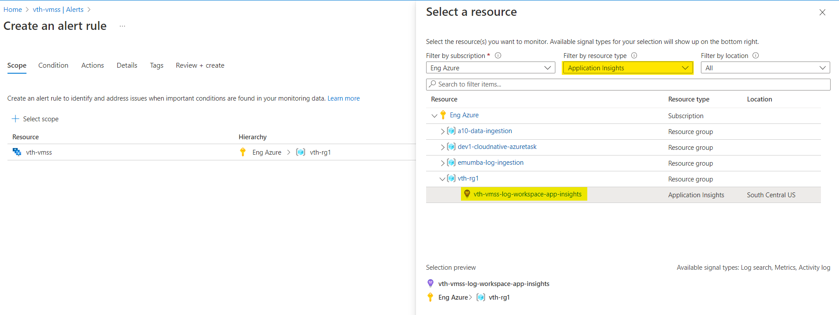

Done.

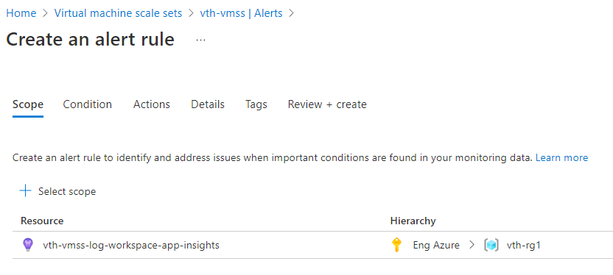

Step 2: Select the “Custom log search” as condition.

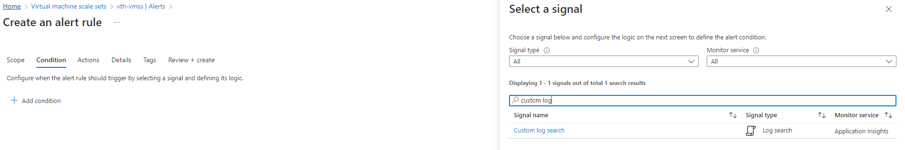Step 3: Write the log query to fetch the data. Specify frequency for alert data.

customMetrics | where value > 85 | where timestamp > ago(30m)

customMetrics | where value > 85 | where timestamp > ago(24h)

customMetrics | where value > 85 | where timestamp > ago(7d)

* 1. Configure signal logic and alert logic condition.

* 1. After the configuration signal logic you will be see the cost for the alert.

* 1. Create the action group.

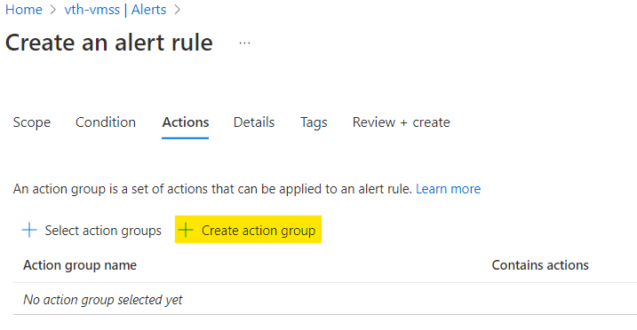

* 1. Fill out the basic information regarding your alert eg. Resource group, name of the alert.

* 1. After Basics info go the notification tab, select the Notification Type and provide the email information regarding email id and click on Ok.

* 1. Give the unique name for the notification.

* 1. Skip the Action and Tags tab.
  2. Review + Create
  3. Once done.
  4. Click on ‘vThunder-CPU-Alert’ newly created alert.
  5. Switch to tab “Test action group (preview)”
  6. Select the sample type for the alert. Billing alert.
  7. After the test click you will see the running status for test rule.
  8. Once status will succeed you will get the email on given email id.

* 1. Click Create

### 2. Autoscaling using Azure Functions Setup

In case you have already setup autoscaling as above, please ignore this. Any one type of autoscaling configuring is allowed.

In this case azure function will periodically maintain vThunder CPU Utilization. And do the autoscaling as per automation account threshold configuration with variable name “ThresholdForScaleOut” and “ThresholdForScaleIn” for Scale Out and Scale In respectively.

vThunder Logs can’t been seen on azure log analytics dashboard.

Autoscaling metrics logs can’t be seen on azure application insight -> log console.

#### Install

“.\PS_TMPL_3NIC_NVM_VMSS_FUNCTION_APP_4.ps1”

#### Configure

Please refer PS_TMPL_3NIC_NVM_VMSS_FUNCTION_APP_PARAM.json file

functionAppName: Any name for functions.

applicationInsightsName: Get from azure.

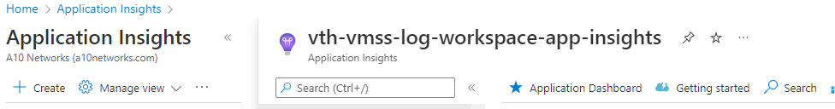

subscriptionId: Azure account subscription ID

filePath: Identify files along with scripts.

1. GetMetrics.zip file contains below files.

* + 1. AutoScaleVMSS
    2. GetCPUMetrics
    3. .funcignore
    4. .gitignore
    5. host.json
    6. requirements.txt

2. Provide the GetMetrics.zip absolute file path in “filePath” parameter.

e.g.: " C:\Users \a10-azure-arm-templates-internal\ARM-TEMPLATES\ARM-3NIC-VMSS\AZURE_FUNCTIONS\GetMetrics.zip "

#### Verify

After deployment verify functions and files deployed on Azure portal

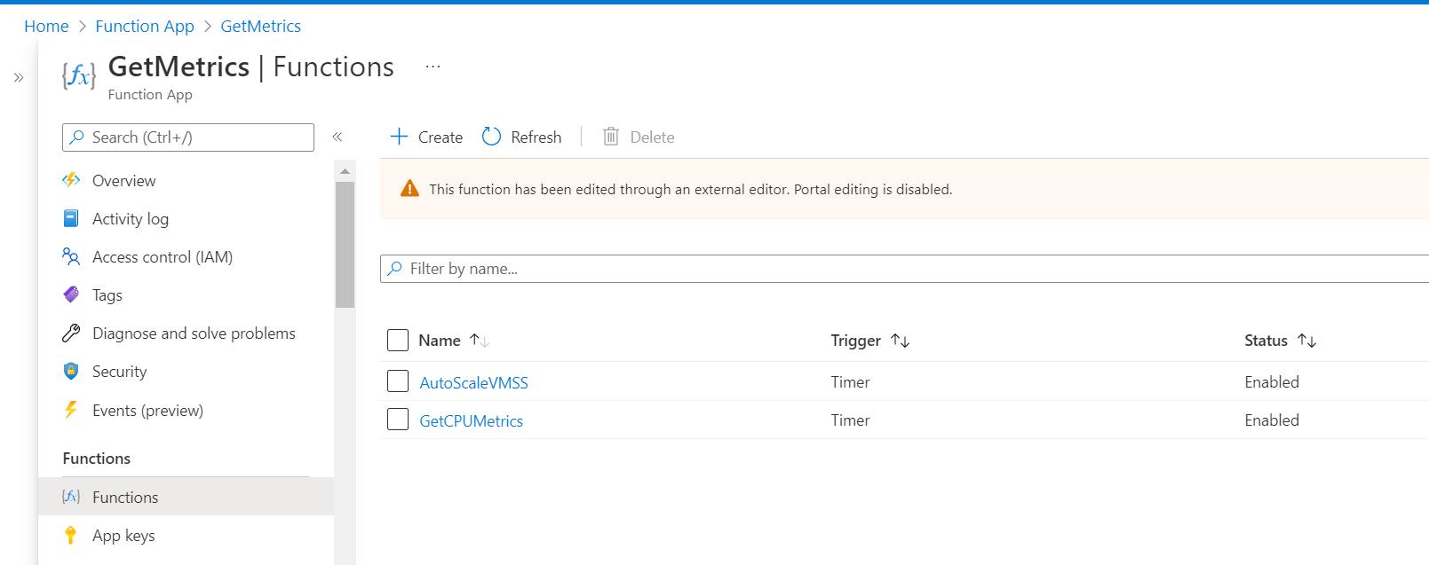

1. function app -> configuration

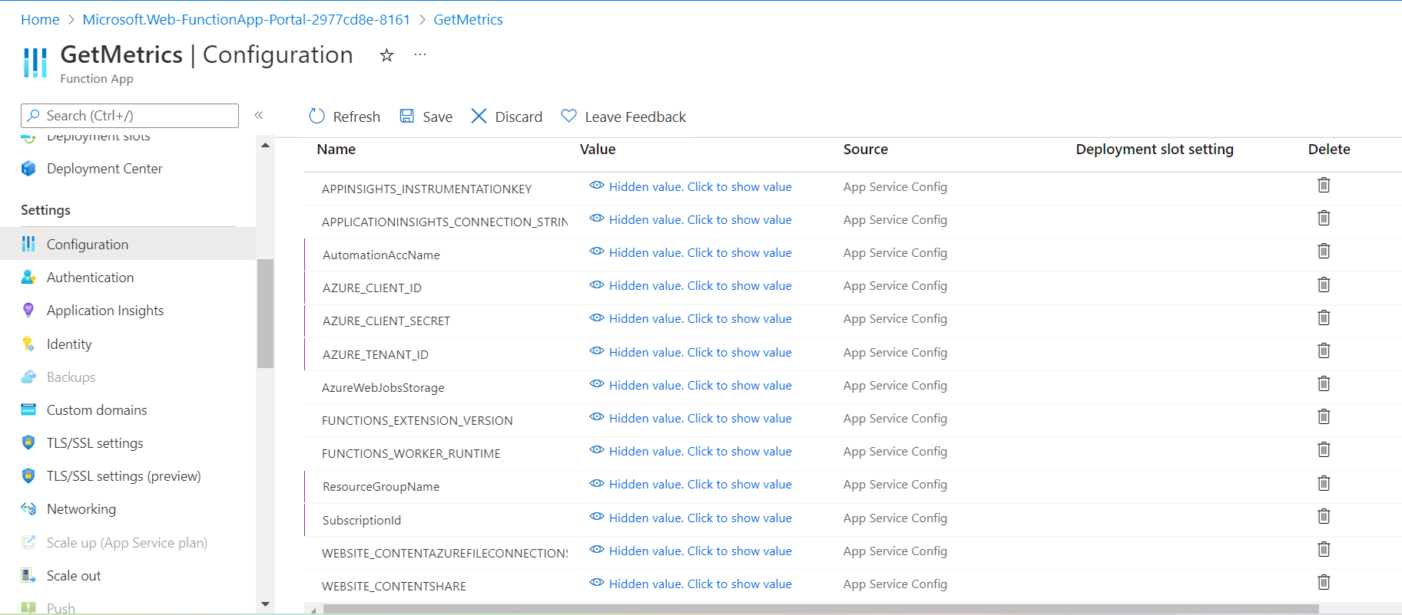

#### Logging:

Logs which are generated by functions can be viewed under monitor section.

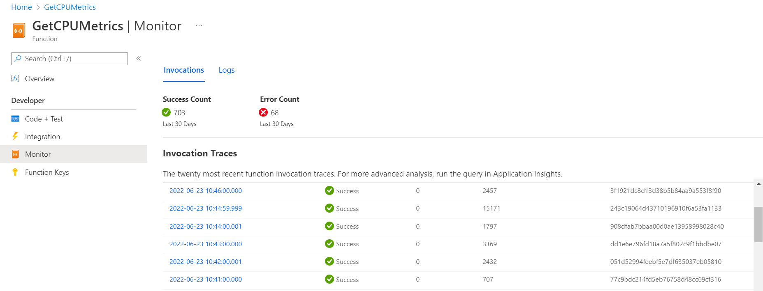

Check Azure function logs documentation [here](https://docs.microsoft.com/en-us/azure/developer/javascript/how-to/with-web-app/azure-function-resource-group-management/view-query-application-logs#query-your-azure-function-logs) for more information on log queries.

## Chapter 5 - Let us Verify.

### Login to vThunder

vThunder can be access by ssh to instance or GUI.

SSH to vThunder Instance:

Open putty and connect.

IP: Get from Azure Console -> Virtual Machine scale sets -> vth-vmss -> Select Instance -> public IP.

User Id [Default]: admin

Password [Default]: a10

After login.

Execute Command -> enable

Password -> <just press enter>

#### vThunder GUI Verification

GUI: Check below vThunder GUI

Web URL: http://IP

<https://ip/gui/auth/login/>

#### SLB Verification

After Successfully run master webhook you can see your slb config on vThunder, refer below image

#### GLM License Provision Verification

After Successfully run master webhook you can see your GLM license on vThunder, refer below image

#### GLM License De-Provision Verification

After Successfully run master webhook you can see your license on vThunder GUI in history section, refer below image

#### SSL Certificate Verification

After Successfully run master webhook you can see your ssl config on vThunder, refer below image

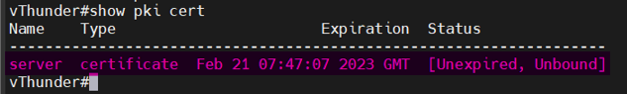

#### vThunder Logs Sync-up Configuration Verification

Go to vThunder cli console.

Run ‘show running-config’

